Overdale Community Primary School
Year 4 Spring Term 2 - 2025
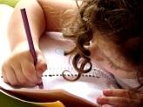  Literacy  In our Talk 4 Writing this half term our fiction focus will be writing stories with descriptive and actions based openings and endings. We will use our new text ‘Zelda Claw and the Rain Cat to help guide us through our writing. Our non-fiction text will be a discussion text where will discuss the question ‘Should Rain Cat’s be allowed to live on earth?’ | 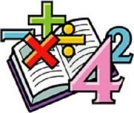  Maths  In maths, we will complete our work on subtracting fractions. We will also be looking at measuring the perimeter of different shapes and then focusing on our knowledge of decimals. All of our work on fraction will help us with looking at decimal equivalents and knowing that decimals can help us to show parts of a whole.. |   Science  Sound continue to be our focus in science this half term. We will be looking at the pitch of sounds and how we can change the pitch. We will move on to Animals including Humans part way through the half term and we will look at the different types of teeth humans have and their functions. |   Computing  In computing we are developing our knowledge and understanding of HTML and using it to help us understand websites more.  We will also be linking our Maths to computing and practising our TT Rockstars too!
  Humanities  This term we are studying Geography, we are looking at Migration, identifying countries, cities and capitals. We will develop our map skills and the use of an Atlas!  . | Our class book  The Boy Who Met a Whale  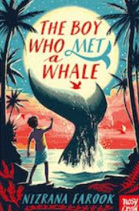 |  | PSHE  We are continuing our unit from the previous half term- Safety and the Human Body.  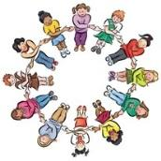  We will start to look at puberty and making healthy choices.
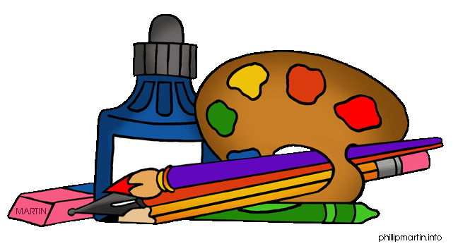  DT  Throughout this unit we are looking at Slingshot Cars. We will Design and ultimately create our own versions using different and appropriate materials! |   PE  For games this half term, we will be doing Dodgeball where we will be perfecting our collaborative and team work skills and be perfecting powerful and accurate movements.  We will also be doing some Roman themed dancing. |   French  In French, we will be revisiting out Science from the autumn term, but this time in French.  We will be learning different phrases to describe the weather and even have a go at describing the water cycle in French! |   RE  The key question this half term is why do some people find Jesus inspiring. We will also be looking at the Easter story.  Music  In Music, pupils begin crafting their compositions with greater complexity, incorporating pentatonic scales and rhythmic patterns

